**How to make a business name and a logo.**

To create a name, you can use Namelix: <https://namelix.com/>

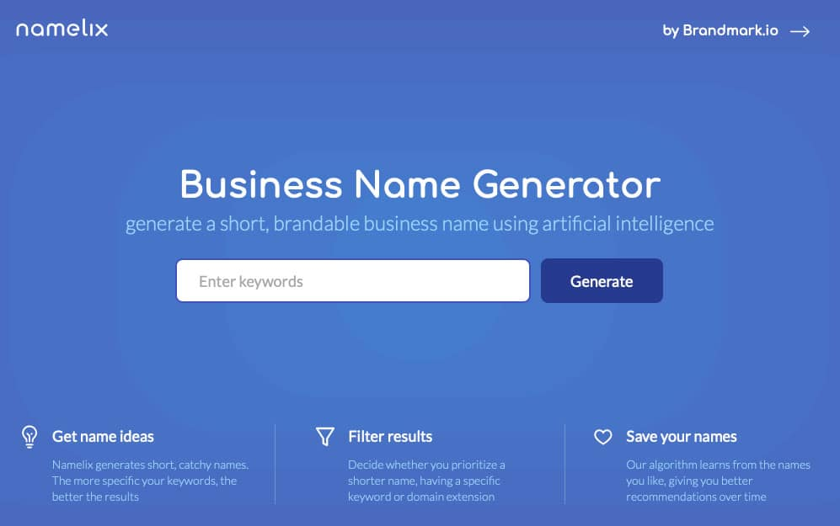

This is a fast way to create names with just a few keywords.

To create a logo, you can use launchaco.com: <https://www.launchaco.com/logo>



Here you can make a logo easily.

Dit hebben we gebruikt om onze naam en logo te maken.